Table tayorlash: [mockaroo.com](https://mockaroo.com)

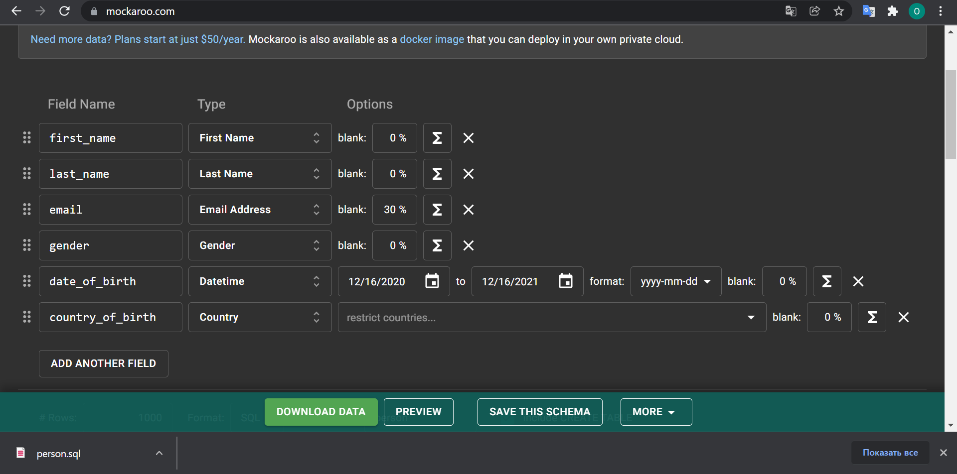

Uni vs code da ochish:

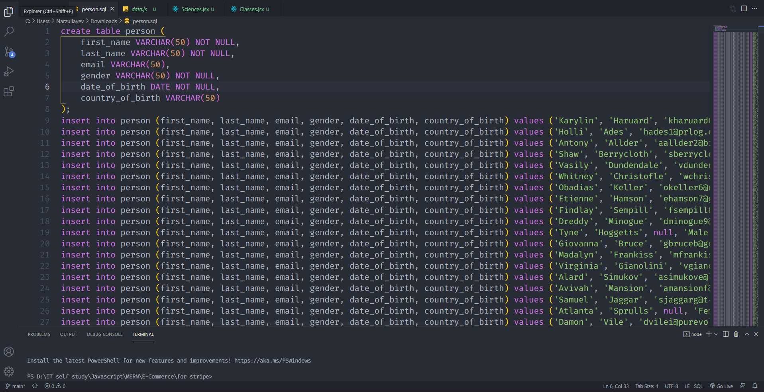

Removing dublicates => Distinct

1. COALECSE

Bu bo’sh maydonni nimadir bilan to’ldirish: [sharti qiymatlar bir xil tipda bo’lishi kerak]

COALECSE(A, B);

A – ustun nomi;

B – o’sha ustundagi bo’sh katakka qo’yiladigan qiymat;

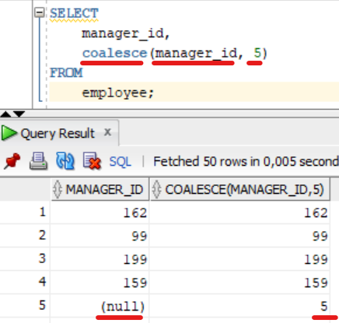

NULLIF

SELECT NULLIF(A,B); agar a va b teng bo’lsa NULL qaytarib beradi bo’lmasa A ni qaytaradi. Bu qachonki 0 ga bo’lishdan himoyalanish uchun kerak.

Misol:

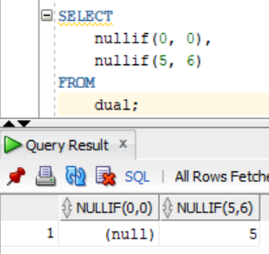

0 ga bo’lish xatosidan qutulish yani A/0 = A deb ketish:

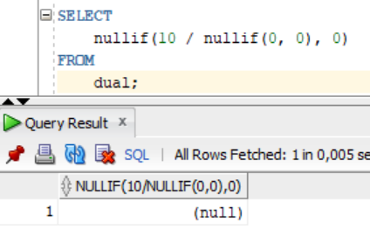

EXTRACING FIELDS FROM DATE

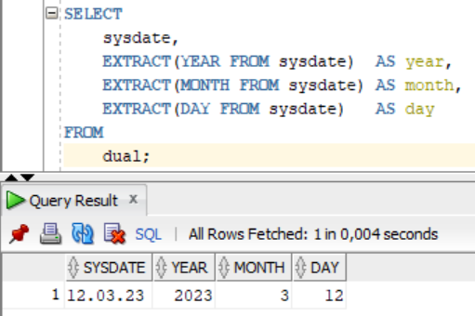

CHECK CONSTRAINS => CHEKLOV QO’YISH

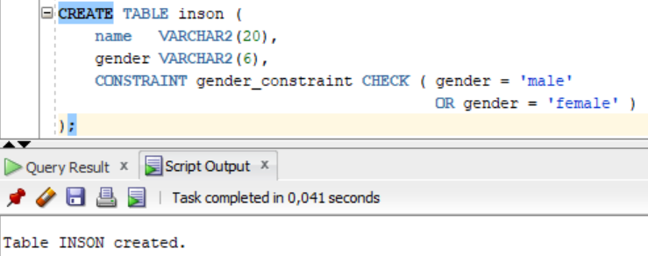

1. UPDATING RECORDS

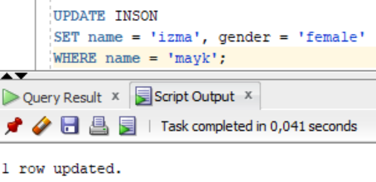



DELETING FOREIGN KEYS:

Bunyodga mashina yozamiz:

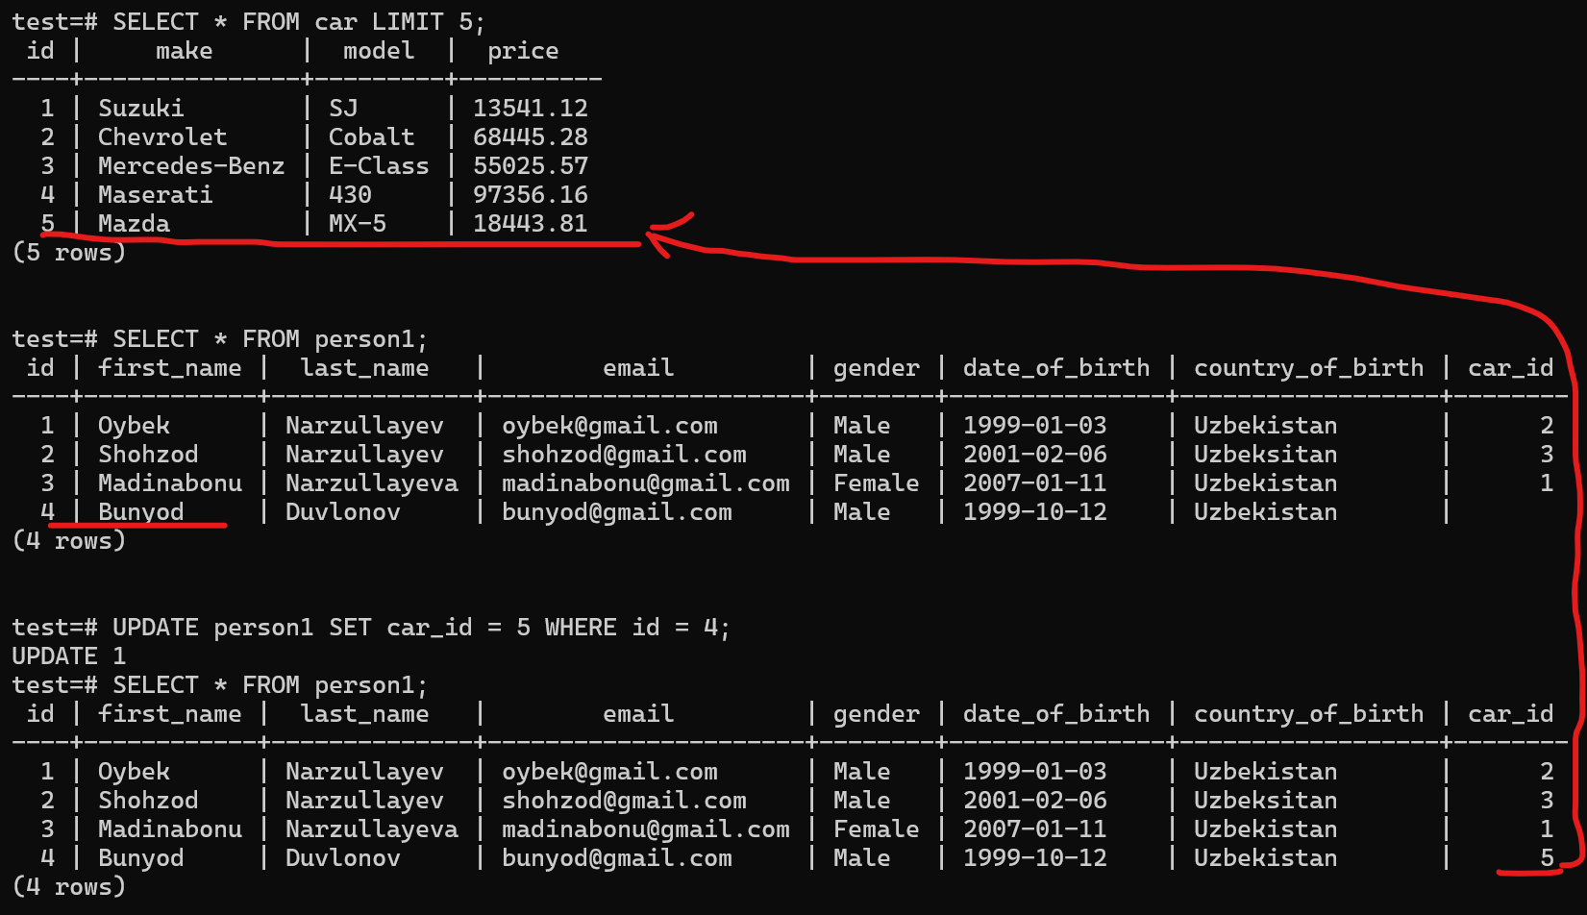

Endi men id = 5 bo’lgan car ni o’chirmoqchi bo’lsam xató beradi chunki u person1 dagi Bunyodning car_id siga ulangan.



Bu bu ishni bajarishim uchun men avval person1 dagi bunyodni car_id sini NULL ga yangilashim kerak yohud Bunyodni ma’lumotlarini jadvaldan o’chirishim kerak! So’ng men id si 5 ga teng car ni o’chirsam bo’ladi;